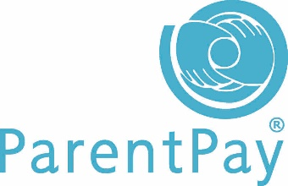
An introduction to the
online payment service and cashless catering
www.parentpay.com
What does ParentPay do?
- enables you to pay for Dinner Money and other items such as Trips
- offers a highly secure payment site
- gives you a history of all the payments you have made
- allows the merging of accounts if you have more than one child at school
- shows you all items available for payment relevant to each of your children
- emails a receipt of your payment to the email address you register

How does ParentPay help you?
- gives you the freedom to make payments to school whenever and wherever you like
- stops you having to write cheques or search for cash to send to school
- gives you peace of mind that your payment has been made safely and securely
- helps with budgeting; payments are immediate, there is no waiting for cheques to clear
- payments for many of the larger trips can be made by instalments up to the due date
- ParentPay is quick and easy to use

What are the benefits of Cashless Catering?
- It will speed up the service so that students have more time to eat and rest
- Students receiving Free School Meals will be invisible to their peers
- It will reassure parents/carers that their children are spending dinner money on a nutritious meal
- Eventually we hope to be able to share information with parents/carers about what their child is eating so that we can support them to make healthier choices
- It helps the kitchen analyse the uptake of meals and therefore respond more effectively to what the students want

How do I get started?
We will send you an activation letter to enable you to setup your ParentPay account. The activation letter will contain a personal activation username and password to enable you to login to ParentPay. During the activation process you will be guided through changing your username and password to something more memorable; you can also merge your accounts if you have more than one child.
We are holding a registration day on Wednesday 4th and Thursday 5th October (consent form required) where students will have their finger scanned. We do not store finger prints, it logs some key indicators that the scanner can pick up.
If we do not receive consent then a 4 digit code will be given to students. This is less secure than the biometrics so we encourage all parents to give consent.

The Launch of Cashless Catering
- On Monday 30th October 2017 the kitchens will no longer accept cash over the tills.
- Parents/carers will be required to put money onto their accounts so that their children can purchase dinners.
- Money will be added to the accounts of children who are eligible for Free School Meals automatically each day for the lunch period.
- A single cash terminal will be available for students to add cash onto their accounts. However, we are hoping that the vast majority is added via ParentPay to avoid queues at this terminal.
- Those who do not have access to a payment method can use PayPoint (like paying for metered Electricity and Gas) at local shops

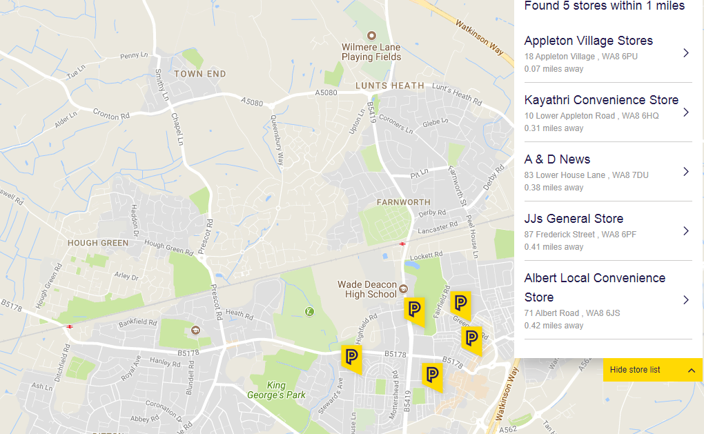
- or to locate a PayPoint near you go to https://www.paypoint.com/en-gb

