- Open a Web Browser (Internet Explorer, Chrome)
- Enter the web address - https://www.office.com/

Click Sign In

Enter full email address
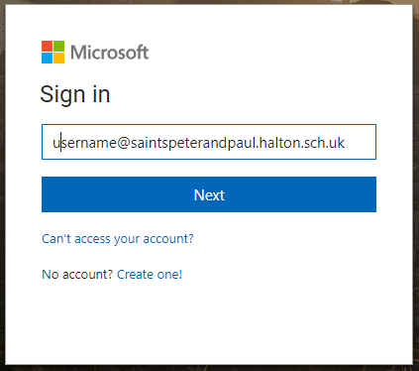

Enter Password
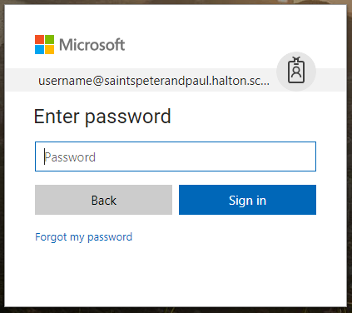

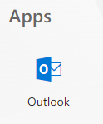
- Under Apps Click Outlook

